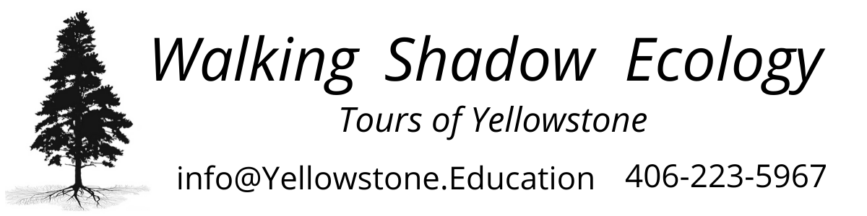

COVID-19 Updates

Winter 2020-2021
A letter from the owner

We believe you can enjoy your Yellowstone experience safely. With some efforts on our part to create as safe an environment as possible, and some flexibility on the part of our visitors, we will all have a safe, memorable time. Our National Park Service-approved Covid Operating Plan includes:
- Installation of a plexiglass barrier between the driver and guests in our spacious Ford Expedition. The front passenger seat shall remain unoccupied. As always, we work to minimize in-vehicle time.
- We ask that while riding in our touring vehicle, all passengers wear a face mask.
- Two 3-layer HEPA air filtration systems running in the vehicle.
- When 6 feet distance cannot be maintained outside the vehicle, we ask that you wear a face mask.
- We will provide disinfectant wipes and sanitizer.
- We will minimize handling of shared resources.
- We will limit our group size to 9 participants per NPS guidelines.
- We will honor full refunds due to travel changes related to Covid-19, minus a $40 booking fee.
- Safety is always at the forefront of our experiences, and we appreciate your assistance in keeping you, our guides, and forthcoming participants safe.
- Read more on the National Park Service Pandemic Response here: https://www.nps.gov/aboutus/news/public-health-update.htm
Please do not hesitate to reach out with questions or concerns. We believe you can have a fun, safe, valuable trip to Yellowstone, and appreciate being a part of your experience.

Ashea Mills, Owner
Walking Shadow Ecology Tours of Yellowstone

